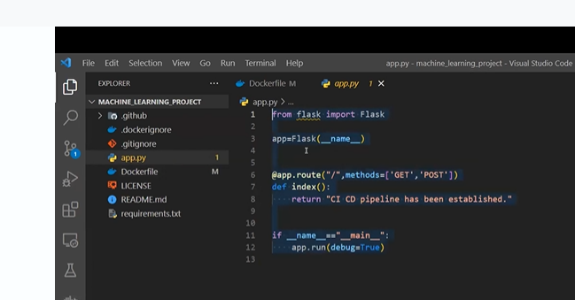

Now create new folder

Housing

Within that folder create file – setup.py

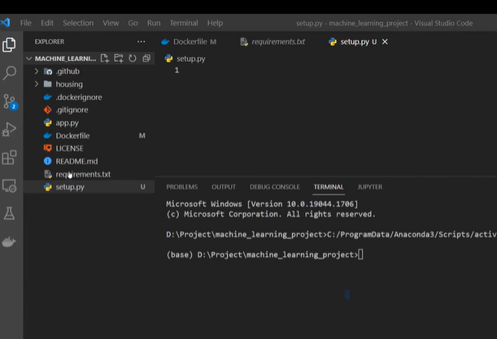

But setup file should be outside\

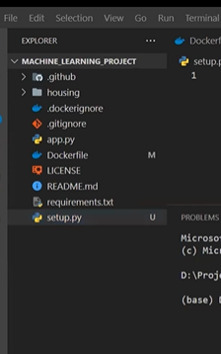

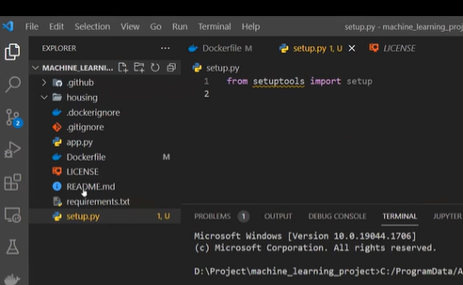

Housing -root/main folder where main code will be there

Setup.py is all about requirement.txt file

No need to write requirement.txt everytime

In housing folder we need to create new file

__init__.py

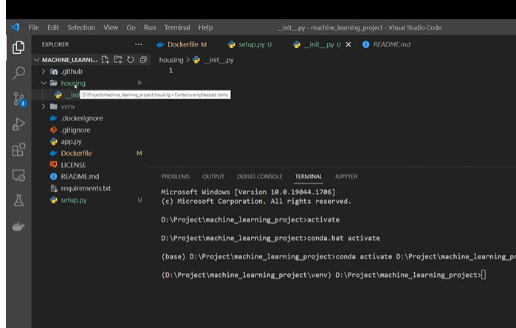

Housing folder is a package

We are going to use this as library

So we need to create __init__

We can use in multiple places

It says it is python module or library

We can import this folder anywhere or any other file Like house flask was imported

Setup.py

Setup() is function

It has many paramerets

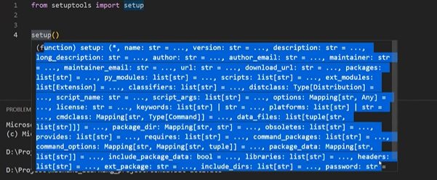

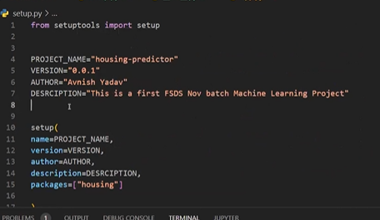

Package= folder name

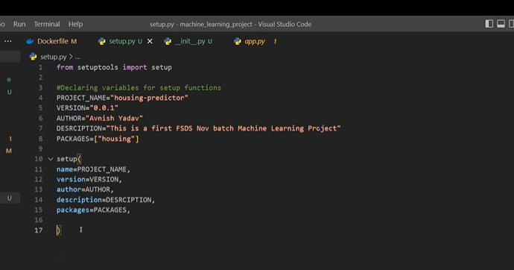

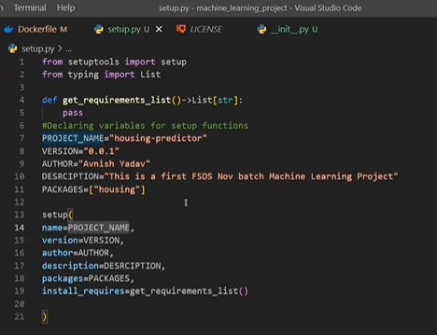

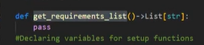

Above function returns list from requiement.txt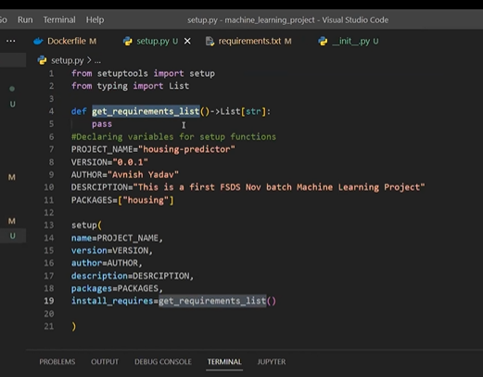

Every datatype in python coming from typing only

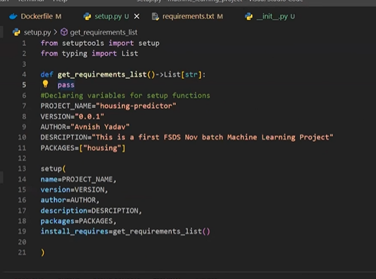

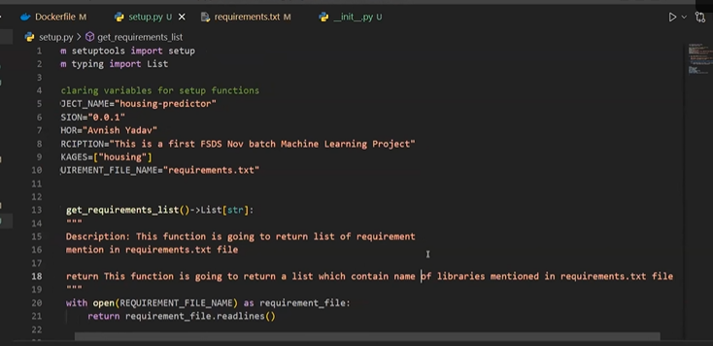

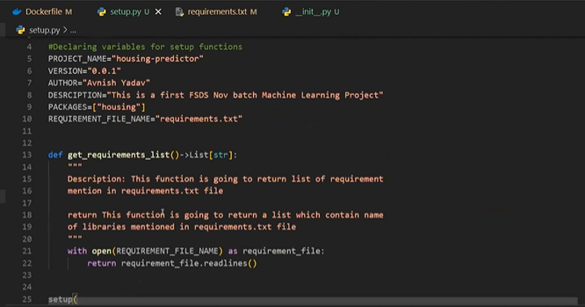

To check whether req.txt working or not

In cmd

Run 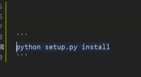

So no need to run req.txt every time

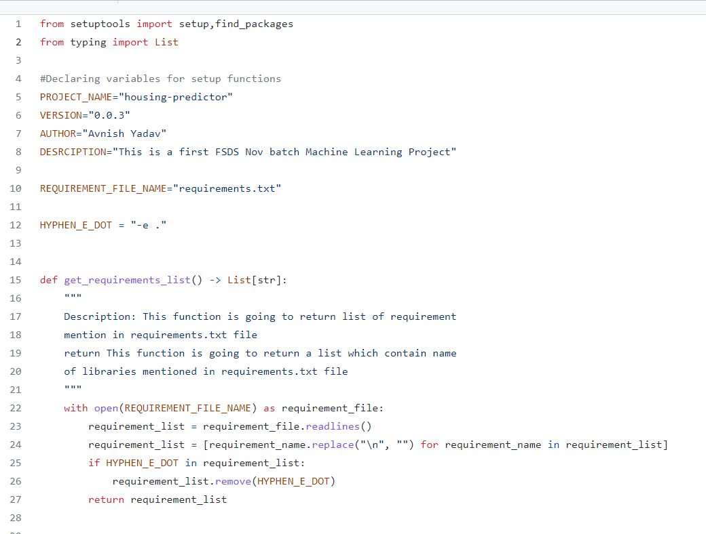

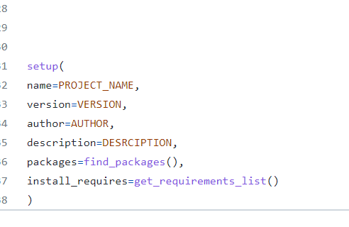

Whenever u rerun setup file we need to change version

Whenever we want to use this project as library then we should create setup.py

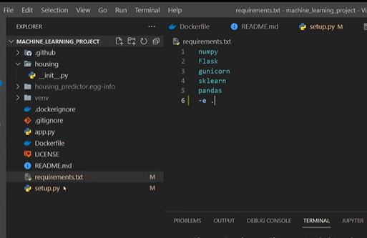

-e.



In req.txt we can add -e.

-e. will install all libraries in housing folder

Check local package as library

Or

We can do in another way

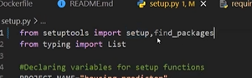

Find_package

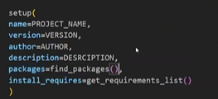

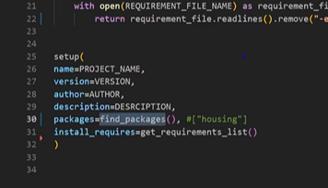

It checks wherever –initi__ it will install packages , or return all packages

We should call find package directly

Instead of giving folder name housing

Once we install dependencies either by pip install setup.py or pip install requirement.txt

This folder will be created

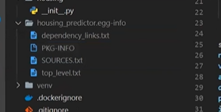

Where ever __init__ is there will be called as package /folder

.py---- as module/file

Whenever we are installing -e.

Setup file should be there

It will install all libraries of housing folder with name mentioned and version

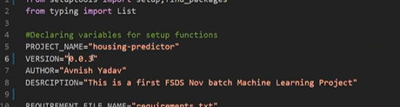

--------------------------------------------------------------------------------------------------------------------------------------

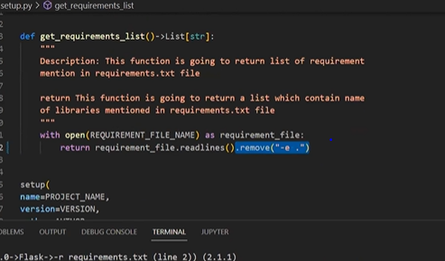

Why we have removed .e

Since we have used find_packages()

Both cant be used

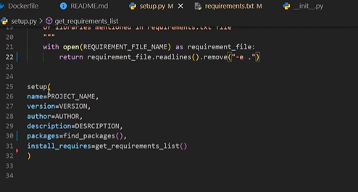

Add demo folder

Inside it

__init__.py

Again try to run requirement.txt

It creates it as package

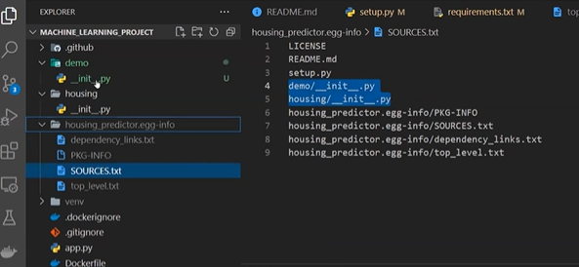

Now remove demo

Whenever we run requiremt.txt it will run -e.

It made run set up function call automatically

What will be structure inside housing folder

1. INIT

2. exception folder (exception became package)

3.logger package

4. pipeline package

5. component /src package (stages or component)

6. config

7. entity

If we are creating folder as package

__init__ must be there

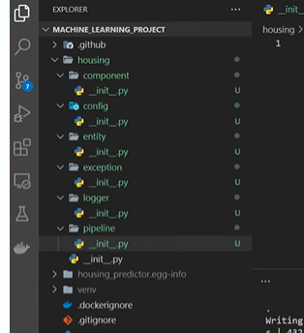

Git add , commit , push

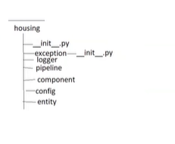

**Which folder we should work first**

**Logger and exception**

At root lever – logger and exception are our root folders

When we are writing code may have errors -handle

To check progress- logger – track everything

Within logger we need to create one more file

We need to maintain one folder logging – logdir

We need to create a file –

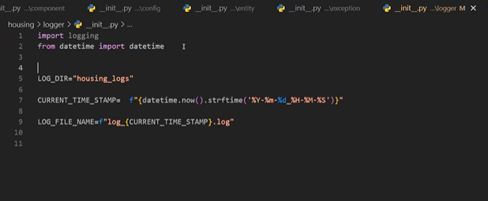

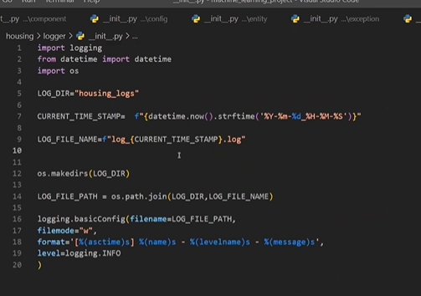

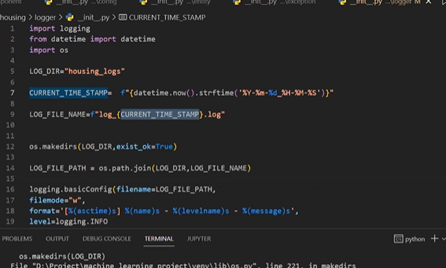

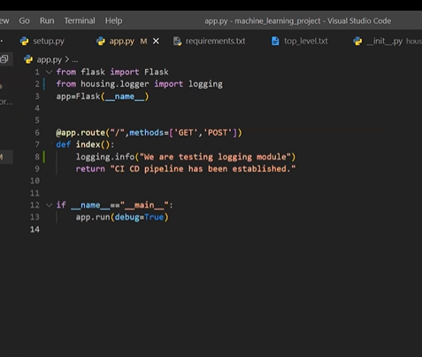

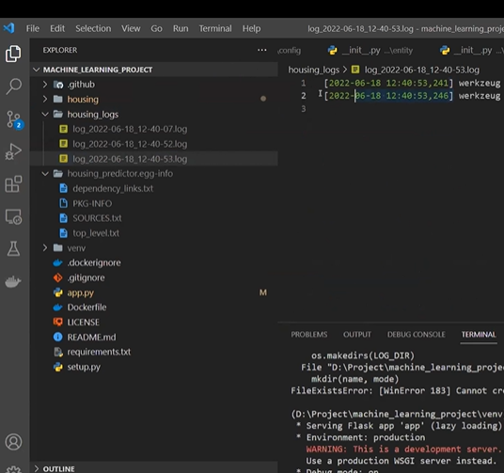

Exception handling

Create our own exception handling

Error_messge: type of exception(it’s a object of exception)

(sys module: have all info about execution , if any exception , which file exception occurred and which line)

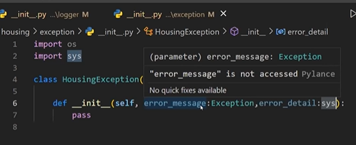

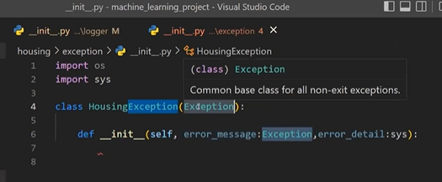

Error_messege,Error_details gets from exception module and sys module

Super is used since we have inherited exception from class Exception

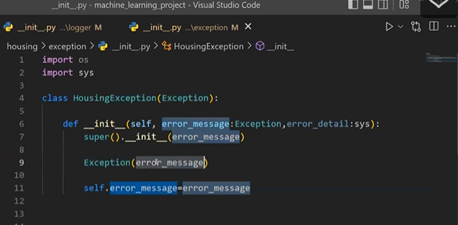

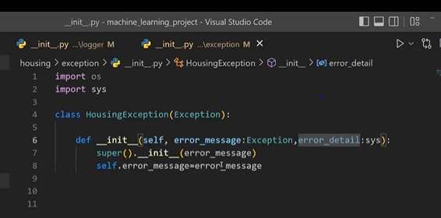

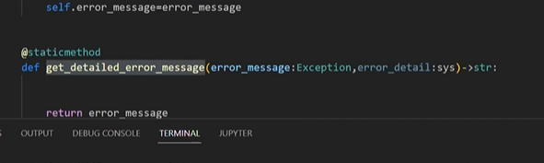

Static method can be called without object

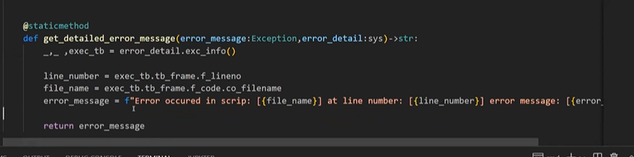

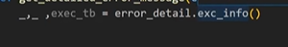\

3 values

Type, values and trace back

We only need trace back info

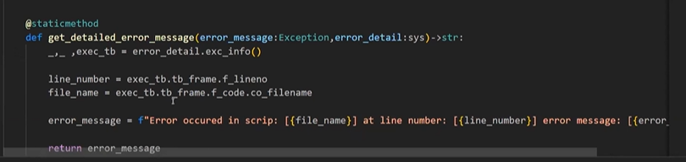

@staticmethod gives error_mesg and details of error in a string format

This method return string

@ static no need to create object

Without creating object we can get error message

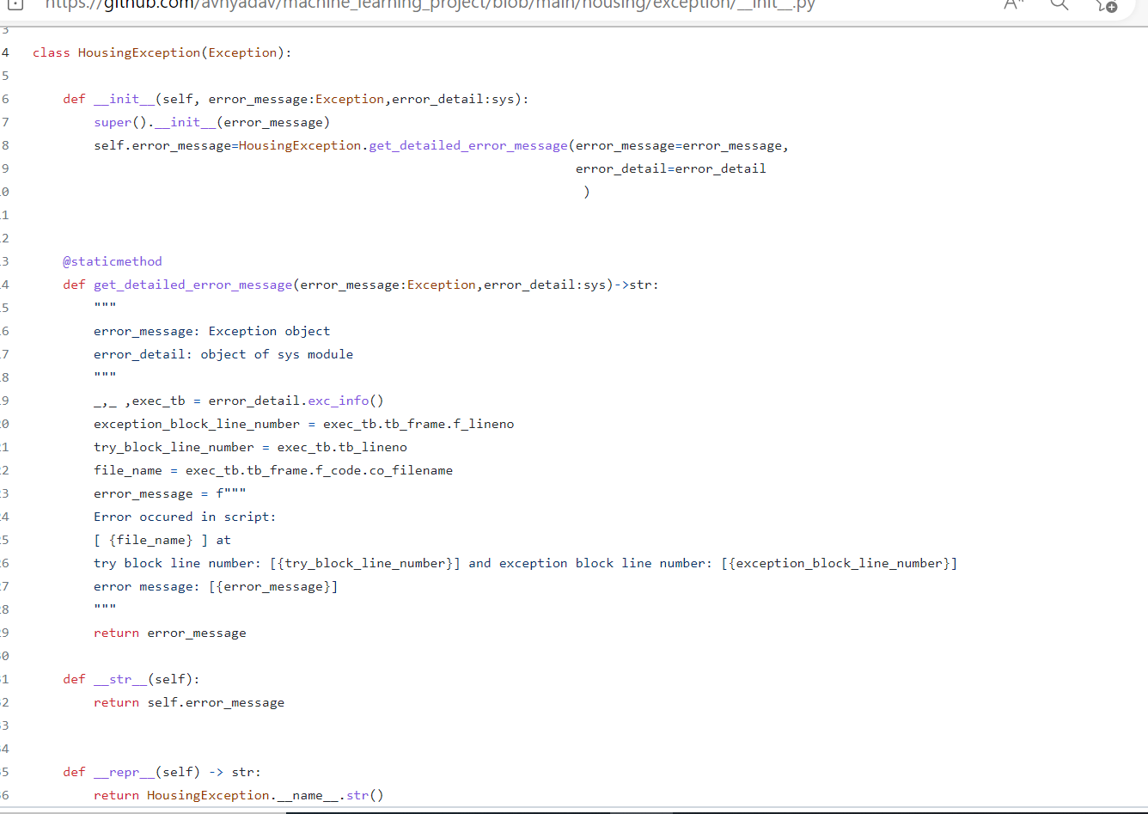

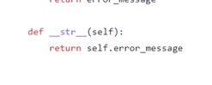

Str is method when we print object of any class what info should be print in obj

--------------------------------------------------------------------------------------------------------------------------

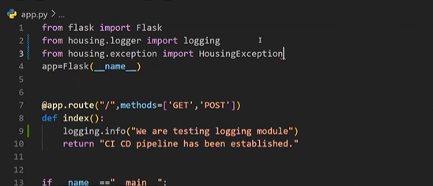

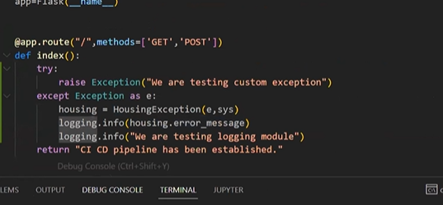

It raised error at line num 13

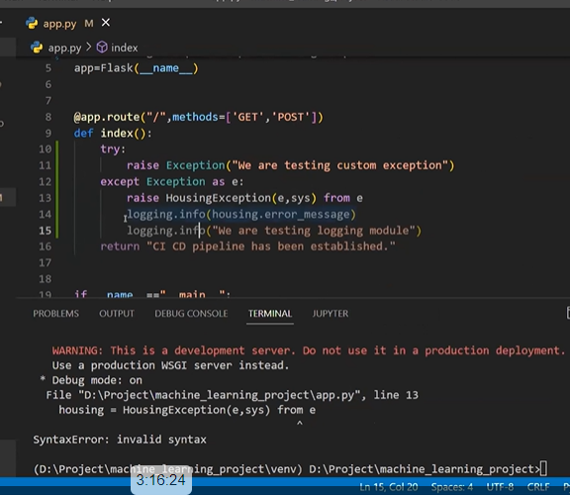

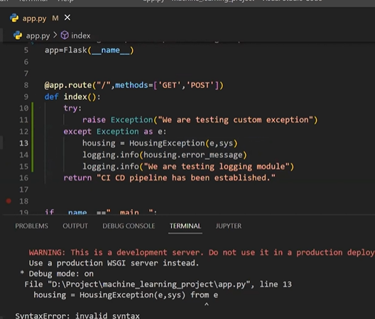

For every .py file

Pycache file will be created

.pyc

Day-3

Use of str:

Whenever I want to print object of any class,

When I want to print obj what should be visible

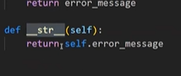

Str is nothing but string format of object

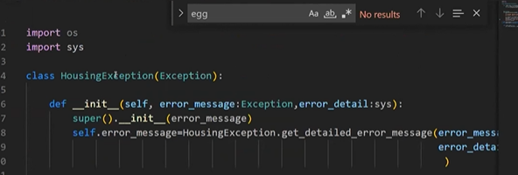

Repr is representation of object

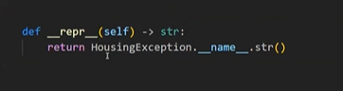

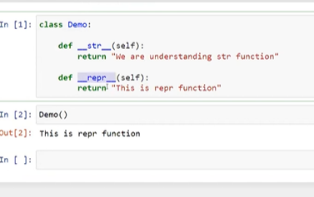

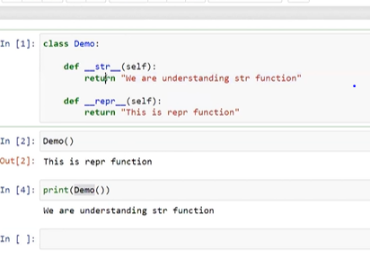

Repr without print statement how object should be visible

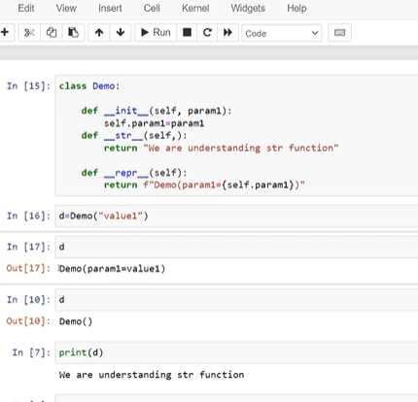

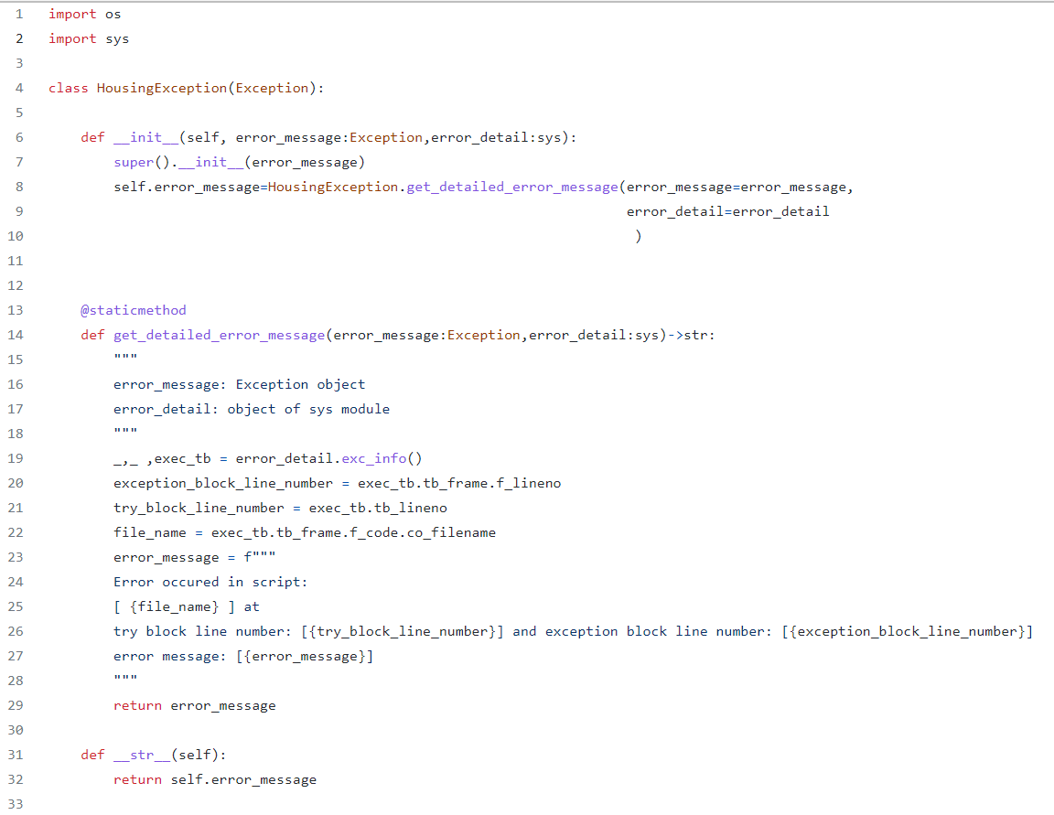

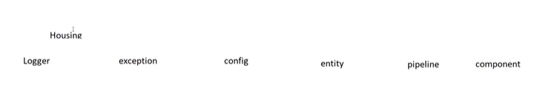

Entity folder ?

What is entity ?

Table is considered as table

Student of class

Machine learning projects: what are entities

To create a project of student management/admission sys:

Entity can be

Student class has entities like id,dob,name…also student class has methods. Each student is entity

Class room

Subj

Dept

Subject

Exam

Anything which has attribute

In machine learning entities are :

In machine learning pipeline components are

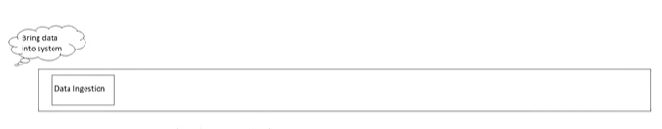

Injestion step only we do train test split

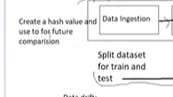

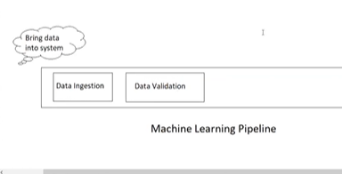

What kind of validation we do?

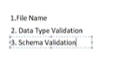

Schema validation/structure of data:

Structure of data:

Like checking columns

No of columns

Checking types

Name of columns

Null check

Duplicate data

Outliers

Imbalance dataset

Domain value

Data Range

Anomalies

datetime

Data drift

DOMAIN VALUE:

Lets take gender as categorical value

Fe, male

Suppose not expected value out of domain came

Expected is fe and male

Ex 2: age -10

Age should be in positives

**Data drift**: data we used in initial training ang generated some statistics and we have received new data and generated statistics.. if there are huge diff in statistics called data drift. Data modified. Called data drift. Cause degradation of model performance. We need to retrain the model

Model drift: we use old model for new data. Model drift

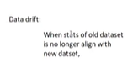



Feature engineering

Generally we do EDA in jupyter notebook

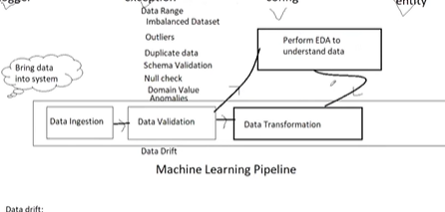

We perform eda to do data Transformations

Data Transformation is also called Feature Engineering

Jupyter notebook is used for EDA and decide which model is performing well

Reducing dimensions also – feature engineering

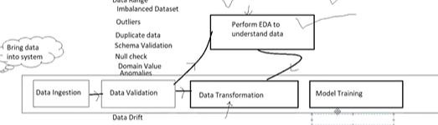

Model Training:

We have 2 model , we try with both and decide which model performing well- Model Selection

Hyperparameter Tuning

Model evaluation (for checking which model performing well)

(if we want to clusters and apply diff model on each cluster- making cluster is also a part of feature engineering)

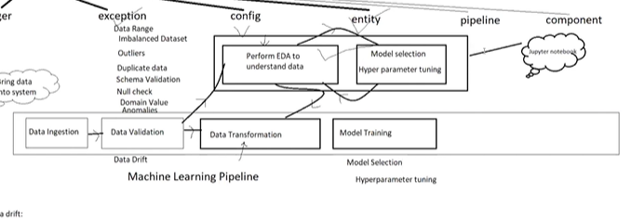

Model Evaluation:

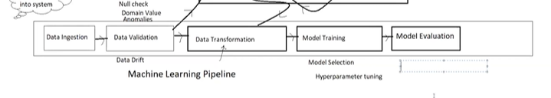

Test data set for model evaluation

Dataset 3 parts

Train

Train

Validation

Train and validation: can be used from validation to training

**Test:** we should not touch before evaluation :

Reason I want to create realistic scenario for model testing when we deploy our model in real world it doent have any info about dataset that will be used for testing

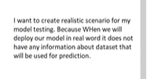

Data leakage

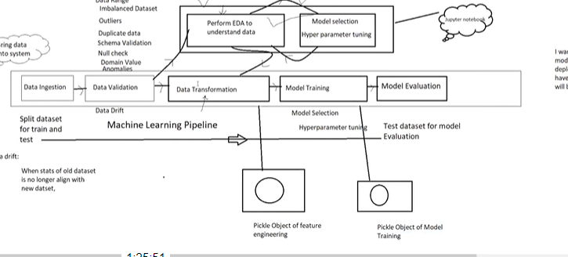

We try to generate pickle object after data Trasformation(this object will have all functions of Data Transformation)

What is pickle?

Saving object into file called – serialization

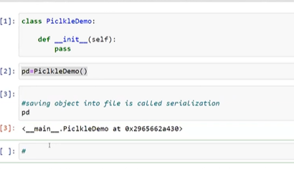

Loading object from file is called deserialization

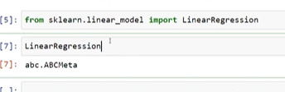

LinearRegression is class

In real world dataset

Prediction pipeline

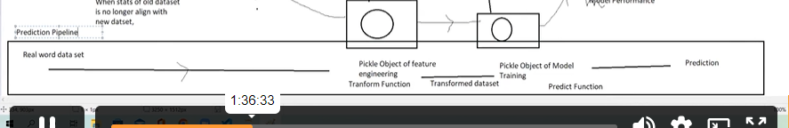

One more evaluation apart from test dataset

Model comparison

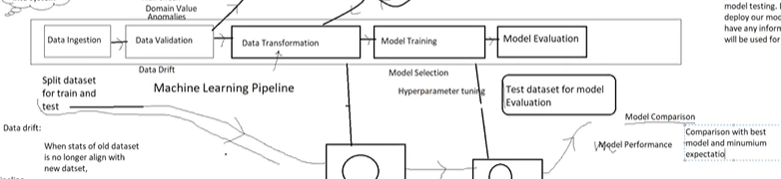

In model training also we performed model comparison.

What kind of comparison we does in Model Evaluation

We can have model which in already in prediction(production)

Now we are training new model

We do comparison with best model and min expectation

Model in production accuracy + 85%

Now trained model -86%

Min expectation : 3%

Atleast 3% more new model should perform well

For example

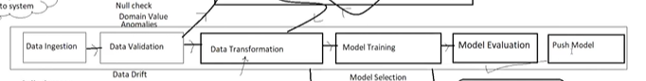

If new model performed well then push that model(saving the model in directory)

Finally we create a pickle file with 2 objects and save the model

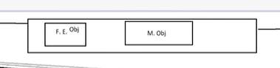

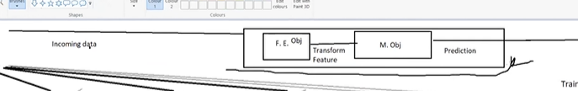

This is our deployment artifact

MLOPS

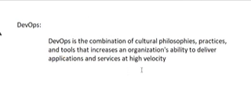

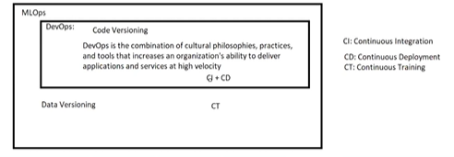

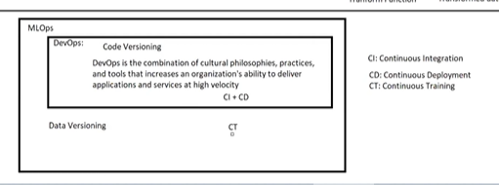

**Data versioning: Creating version of data**

Whenever data has modification – new version of data

If same data used for training : no version

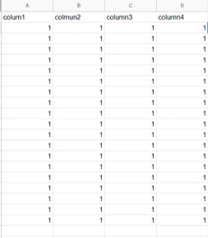

This is our data

Take one more column

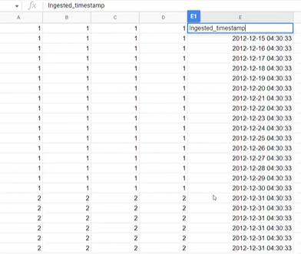

By the last column we can generate version

Groupby by month, week , year – create dataset with version

Dataset before 31st (Ingested time between this time to that time)

Without date can I check whether my data is modified or not:

Num rows, num columns we can check

If num of column and rows same (but inbetween data modified), how can we check?

Hash

Hash for data integrity

If I create hash value for one dataset

Again generate hash value for new dataset

If there is diff: new version

There is python library hashlib which generate hash value for file

Data versioning : 1. Timestamp

2. hash value

Scheduling this pipeline after every 10 days

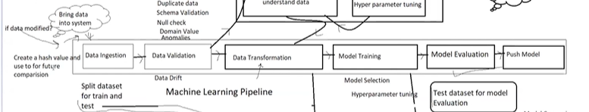

Trigger training]

Called continuous training

It detect datadrift(at data validation) and model drift

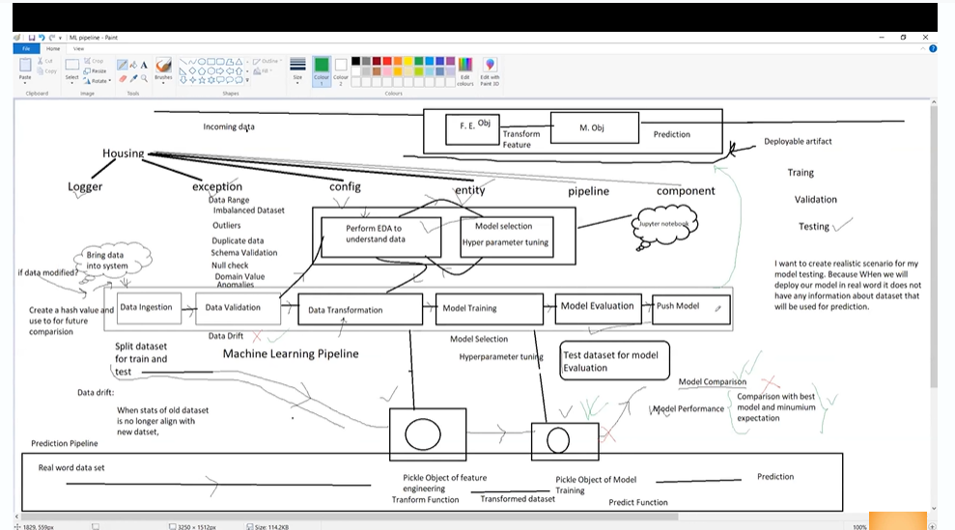

Mlops: all about when new data, when modified code trigger pipleline should able to produce new model

Validation and evaluation: 2 checks

Data check and code check and regeneration of new model by well established pipeline is called – MLOPS

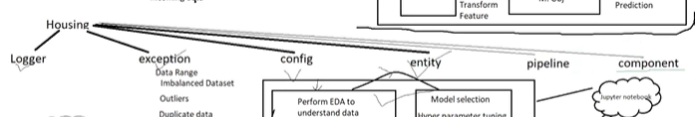Names of components



Every step in pipeline is called component/stage

Component folder we must create number of files

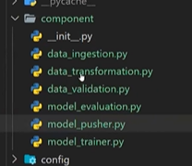

In pipeline folder

We create one pipeline.py file

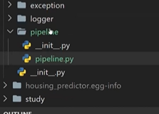

0-------------------------------------------------------------------------------------------------------------------------

Config

Entity

Through entity and config we connect all together and build the project

Ex

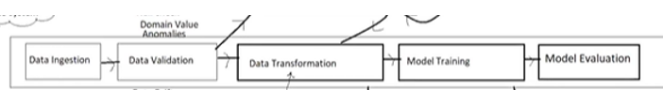

Above is pipeline

For pipeline only we should have config and entity

If we want to start any pipeline, we have some data(any pipeline generate data graph, model, reports statistics)

Any graph of file that machine learning pipeline generates – artifact (something observed in scientific investigation)

When we save our model – model pickle file is artifact

Train dataset and test dataset- artifact

Everything which gets generated in pipeline is called artifact (any graph, model, report,data)

What is structure of artefact how we define?

Any file/graph / anything that’s gets generated during machine learning project: Artifact

In entity we define we define artifacts for every component

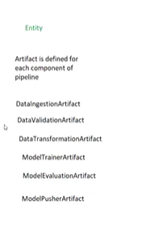

What is structure of artifact? How we define?

In entity we define artifacts for each and every component of pipeline

The output we get from Data injestion component output is called dataingestion artifact

The output we get from MODELTRAINERARTIFACT is called modeltrainer artifact

Config

Before gets artifacts gets generated components of pipelines requires input –

From where it get data(s3,azure,database)- config

To generate artifact it require data/input for component is called config

Data ingestion configuration(input for data ingestion (url, database details)

And we need to provide where it need to save config

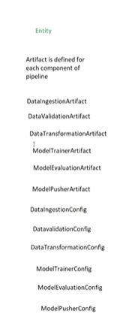

Datavalidationconfig(schema location)

dataTransformationconfig(datapreprocessing config)

modeltrainingconfig(grid parameters)

config: proving some input so that it can perform

to perform some tasks we need some input/ input which required

entity have config and artifact

some of the the artifacts that’s generated will be input for next step

ex: train and test test of data ingestion is input for data validation

in config folder what we are going to create

config.yml

congif.schema

database

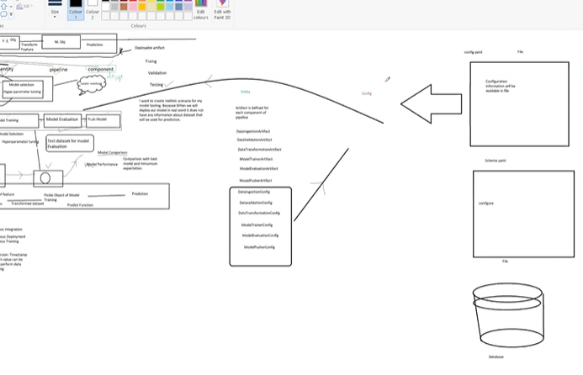

All the configuration information can be write in configuration.py

Config read all files mention in entity

Read structure

From entity config read all component and provide structure to pipeline

Configuration information will be available here

And provide configuration whenever required

Class is user defined entity

Logger and exception will be used everywhere in project

Deployment

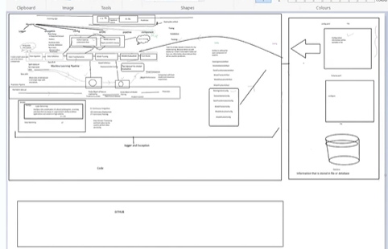

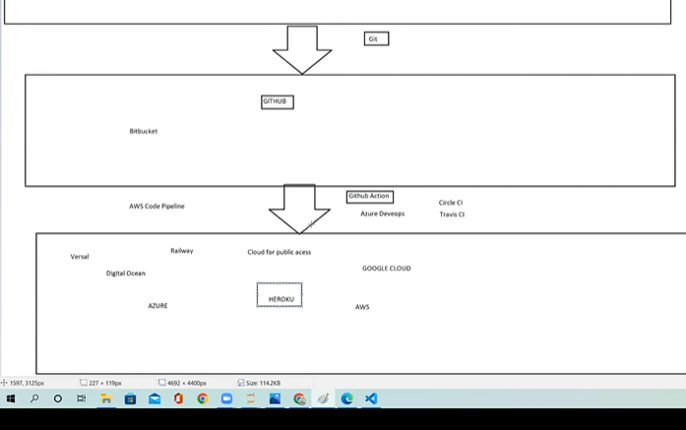

Entity

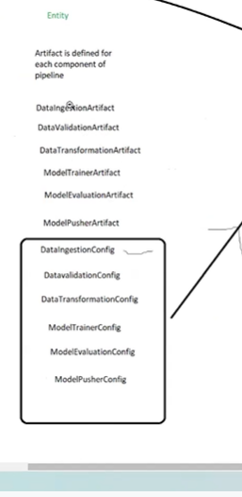

We need to create these many entities

Structure and output of every stage of component

We have entity folder

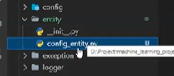

Config_entity.py

We need to specify all configuration information

Config : file through which we will read some info(from file, or any database) optional

This config info will be given to pipeline

-------------------------------------------------------------------------------------------------------------------------------------------

Entity:

Create notebook

Ipynb file

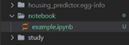

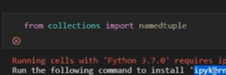

In cmd install ipynb kernel

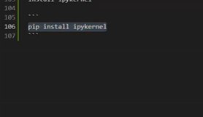

To execute jupyter notebook

Named tuple is also a tuple but every element will have name

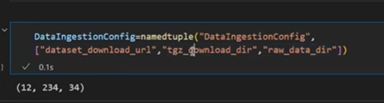

In list download url of dataset

2. download folder in compressed file

3. Download row data extract uncompressed folder

4. train dataset folder

5. test data set folder

We need to specify info into dataingestionConfig

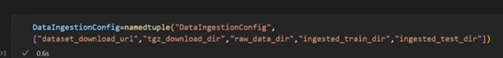

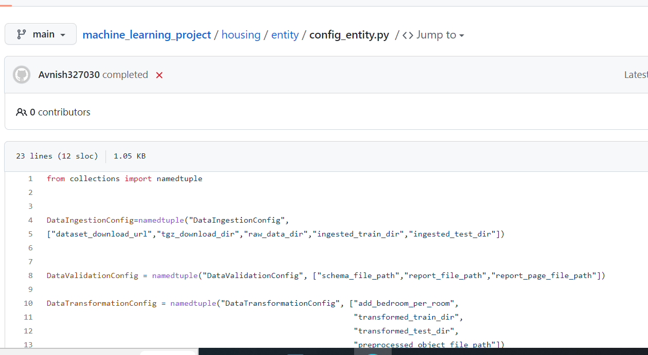

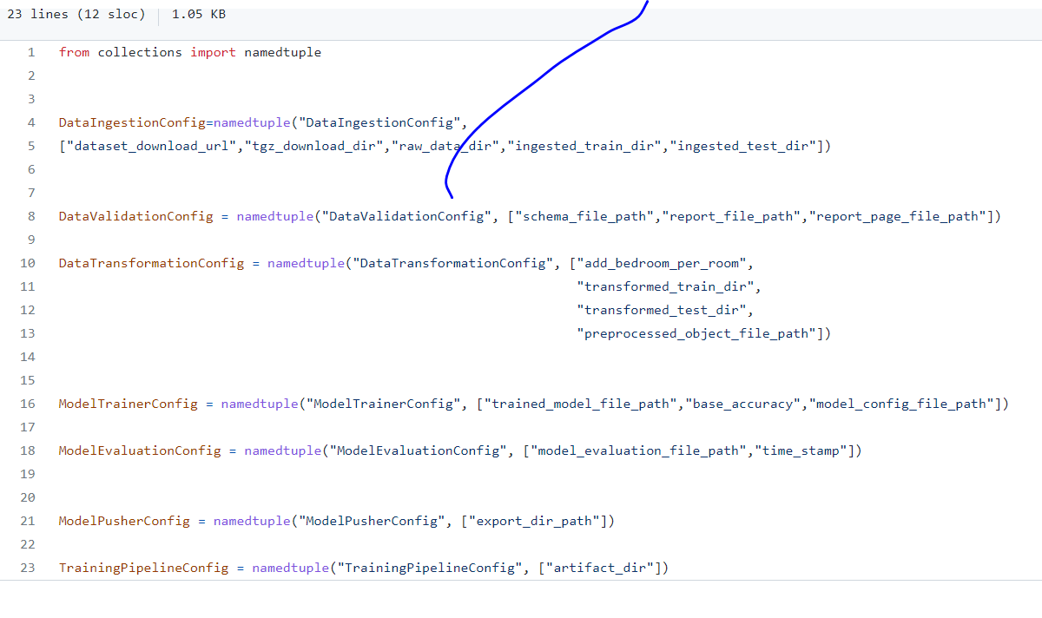

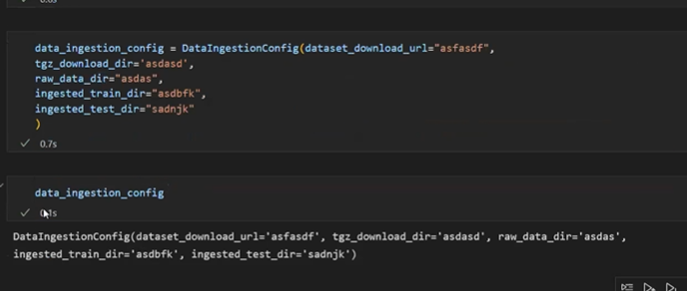

Validation: schema file path

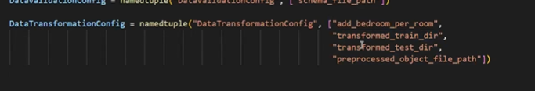

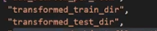--------------- Location

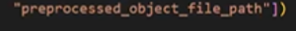;;;;;; Path

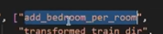- new column created

Config for model training:



Path: to save model

Base accuracy

If new model performs well we need to save in the above path

Model Evaluation:



We use our test dataset to evaluate our model

Compare our model with production model

This file will have path where our prod model stored

Timestamp: what time we compare model

Entity:

In Entity folder

Create file – cofig_entity.py

Namedtuple()

Tuple(12,13,23)

If I can name to every tuple then called as named tuple

In dictionary we can modify values

In named tuple we cant

Namedtuple()- accept 2 parameters 1. Name(we will try to keep the same the same name)

2. list (all variables)

For dataingestioncofig:

We will first download data by url

Where we want to download(dir_tgz(compressed file)

Extractfile : rawdata_dir

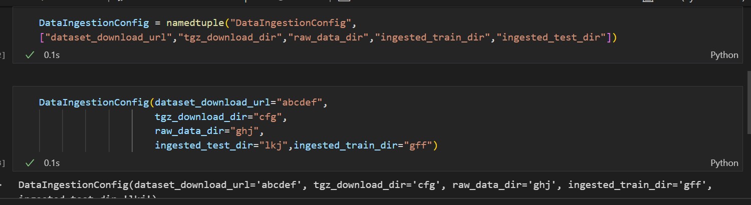

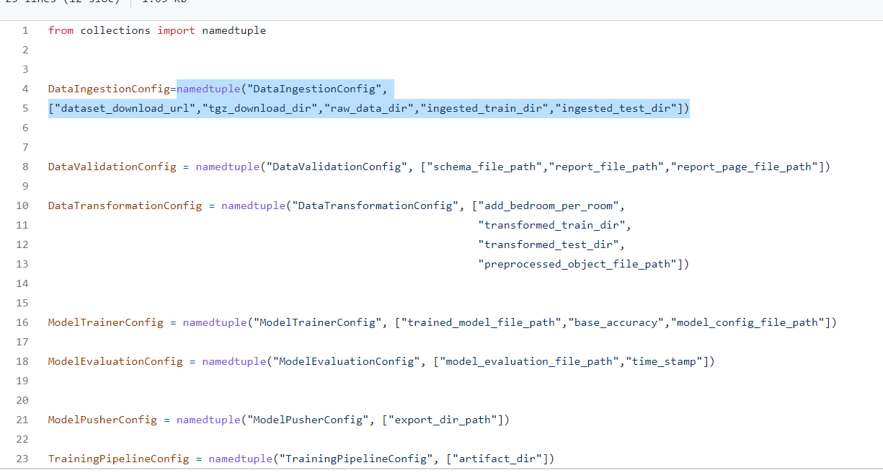

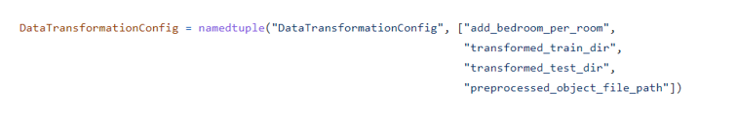

Preprocessed object,

Train dr

Test dr



Trained model file path- where we want to save our pickle file

Base accuracy



Model evaluation file: infor about existing model

We train new model and compare with model in production with base_accuracy

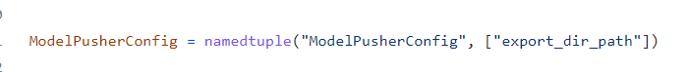

In entity : we are just defining structure , not configuring (we are just mentioning what info we need to supply)

It may b in file or database

This info we will provide through yaml file

We need to provide how and where we need to provide info

Yaml is also a kind of file where we store data like csv, excel , json,java

Data and code is two separate

If I change data I don’t need to change code viceversa

When I run code – code read info from file where we store info

Create yaml file –

Yaml where we store config info

We write code to read yaml file

Config file format

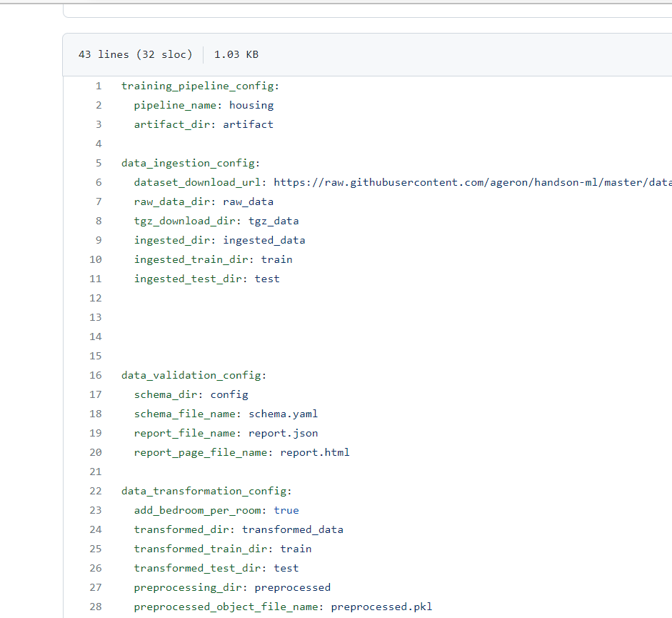

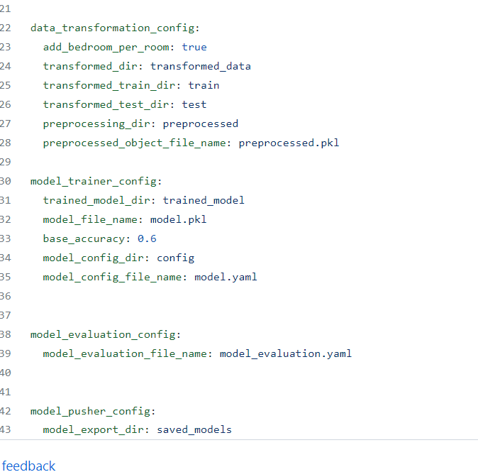

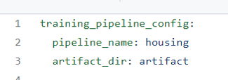

In training_pipeline_config:

Entire pipeline name: housing

Entire pipeline artifact location: artifact

Under this each component will have separate config

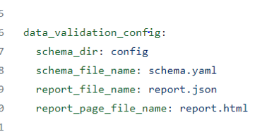

We have entity and config

Now we need to write configuration related code

Now goto

Housing-component-config

As configuration.py

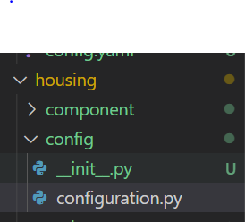

In configuration.py

Cteate a class configuration:

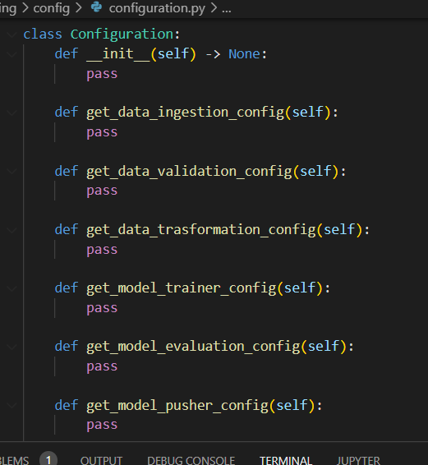

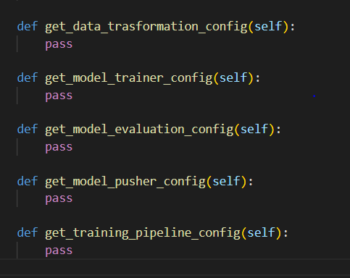

What will be the return value of this each function

Returns entity

We have created entity folder – to know return of each function

Example

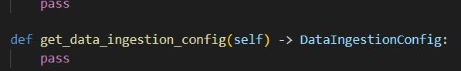

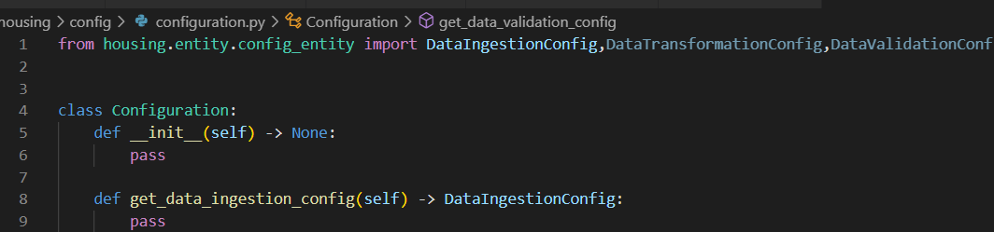

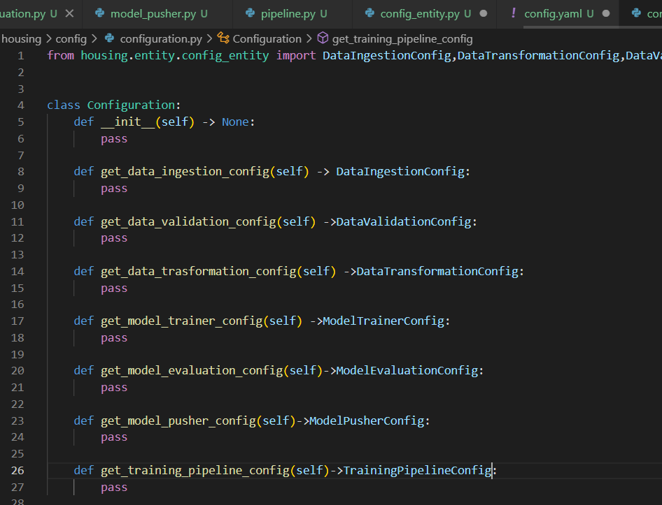

We have yamlfile in config

Entity file

Configuration file in config

Now I need to write a code to read yaml file

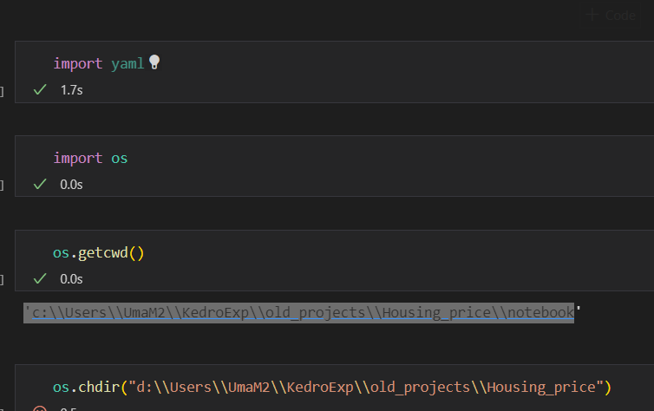

Push model

Produ we need to replace

Path

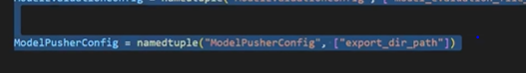

Now create config folder outside of housing

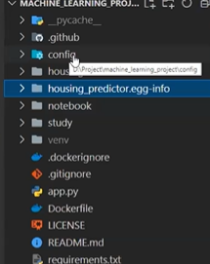

One config will be in housing

One will be outside

Under that create config.yaml file

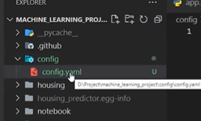

[machine_learning_project/config.yaml at main · avnyadav/machine_learning_project · GitHub](https://github.com/avnyadav/machine_learning_project/blob/main/config/config.yaml)

|  |
| --- |
| training_pipeline_config: |
|  | pipeline_name: housing |
|  | artifact_dir: artifact |
|  |  |
|  | data_ingestion_config: |
|  | dataset_download_url: <https://raw.githubusercontent.com/ageron/handson-ml/master/datasets/housing/housing.tgz> |
|  | raw_data_dir: raw_data |
|  | tgz_download_dir: tgz_data |
|  | ingested_dir: ingested_data |
|  | ingested_train_dir: train |
|  | ingested_test_dir: test |
|  |  |
|  |  |
|  |  |
|  |  |
|  | data_validation_config: |
|  | schema_dir: config |
|  | schema_file_name: schema.yaml |
|  | report_file_name: report.json |
|  | report_page_file_name: report.html |
|  |  |
|  | data_transformation_config: |
|  | add_bedroom_per_room: true |
|  | transformed_dir: transformed_data |
|  | transformed_train_dir: train |
|  | transformed_test_dir: test |
|  | preprocessing_dir: preprocessed |
|  | preprocessed_object_file_name: preprocessed.pkl |
|  |  |
|  | model_trainer_config: |
|  | trained_model_dir: trained_model |
|  | model_file_name: model.pkl |
|  | base_accuracy: 0.6 |
|  | model_config_dir: config |
|  | model_config_file_name: model.yaml |
|  |  |
|  |  |
|  | model_evaluation_config: |
|  | model_evaluation_file_name: model_evaluation.yaml |
|  |  |
|  |  |
|  | model_pusher_config: |
|  | model_export_dir: saved_models |

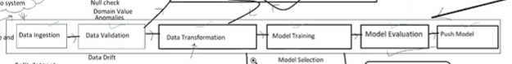

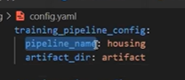

Pipeline name

Artifact_dir – artifact directory (where I save all my artifacts)

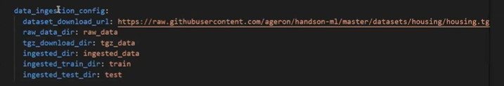

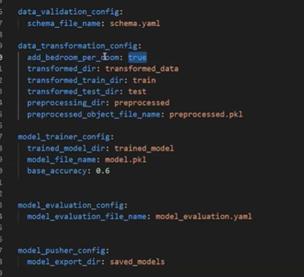

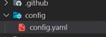

Now go to pipeline (housing)

Go to config folder

Create configuration.py file

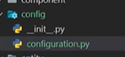

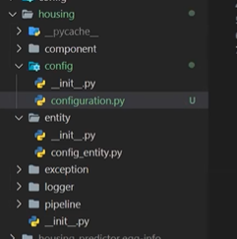

Now in configuration.py

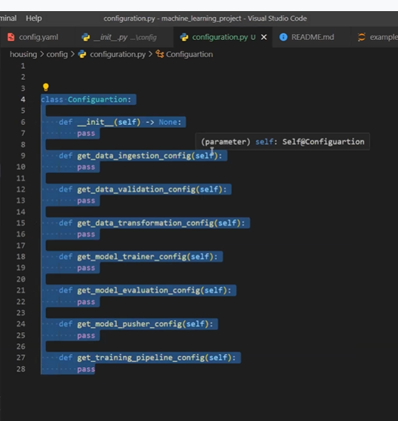

Each function returns entity

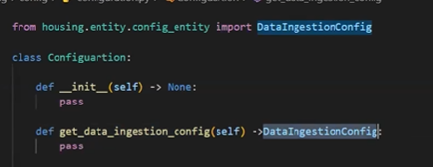

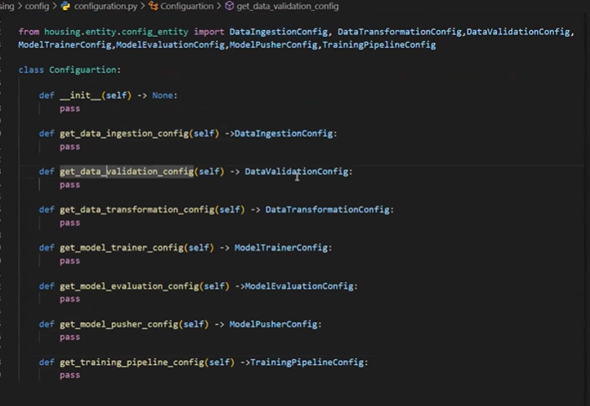

We need to write a code to read the info from yaml file

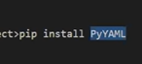

Now we new to go config folder-congif.yaml

Means

Housing_price--- housing- config-config.yaml

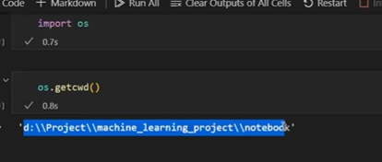

Now to change dir

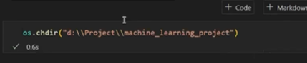

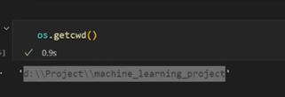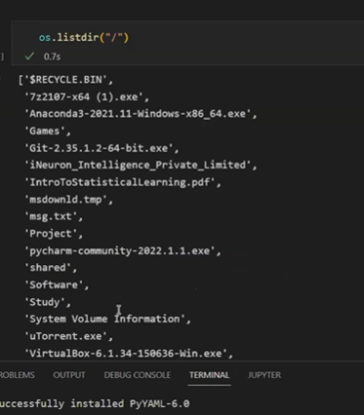

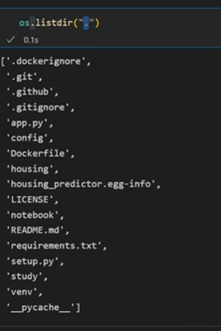

.

“. ”Current directory

folder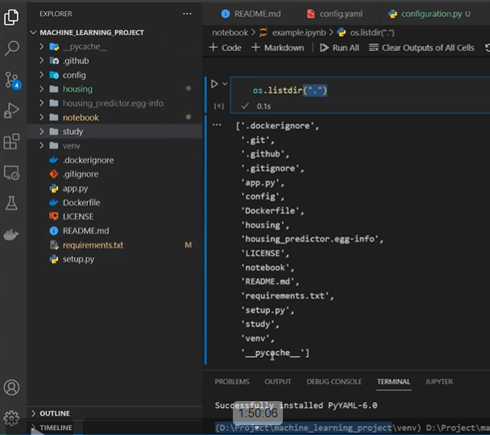

Some files not visible

.git

Open folder

View- hidden items

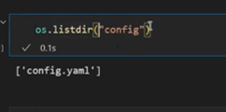

Now to create a path:

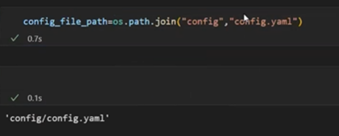

Foldername, file name

To check path exists or not

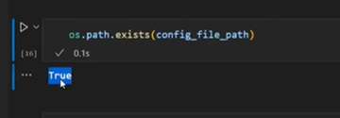

First change directory

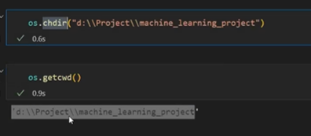

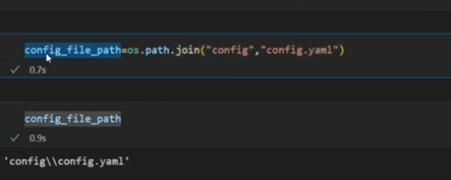

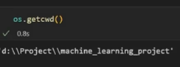

Now how to read a yaml file

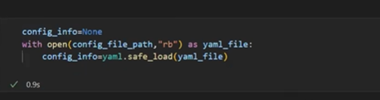

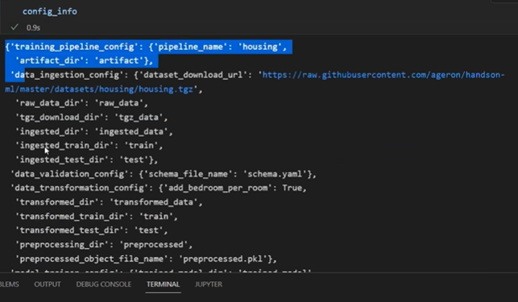

When we read yaml file we will get like dict

In this to get dateingestion config

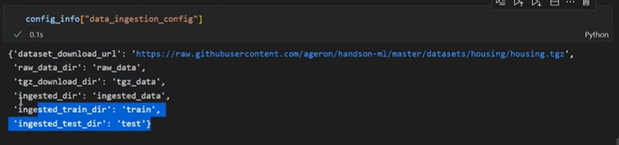

Now we are writing this in function

Try

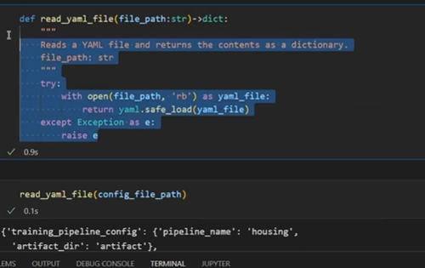

Now in the housing folder we are creating one more folder

Util

We should create __init__.py

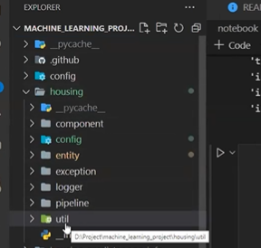

In util create one more file util.py

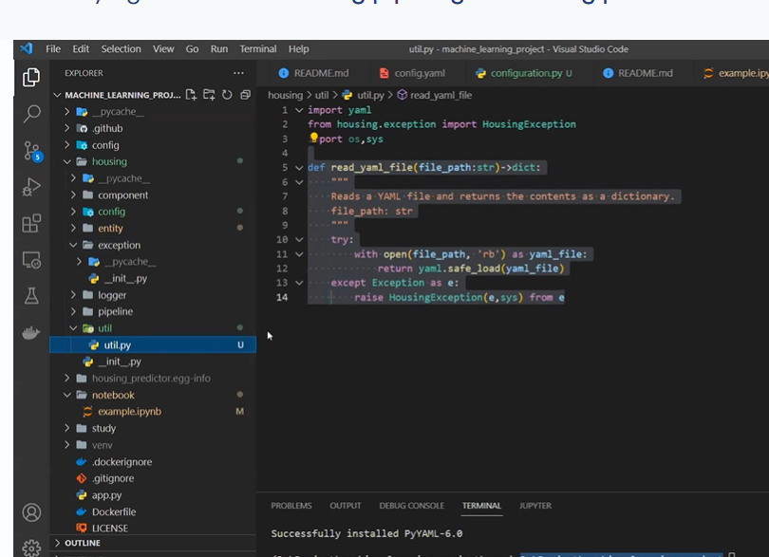

Util is helper function

We will create few functions in utils

These fun we will use when ever required

To read yaml file we need fun so we created util write functon there

We write all helper function there

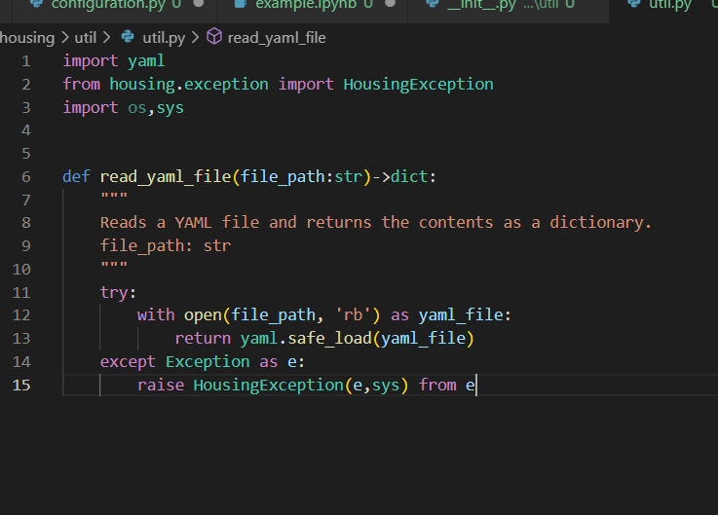

Reading yaml file is not a part of code or project

This will help our project

Not actually a part of project but useful in many placesses

Like creating pickle file and reading pickle file

They are not apart of pipeline

We will import functions like this

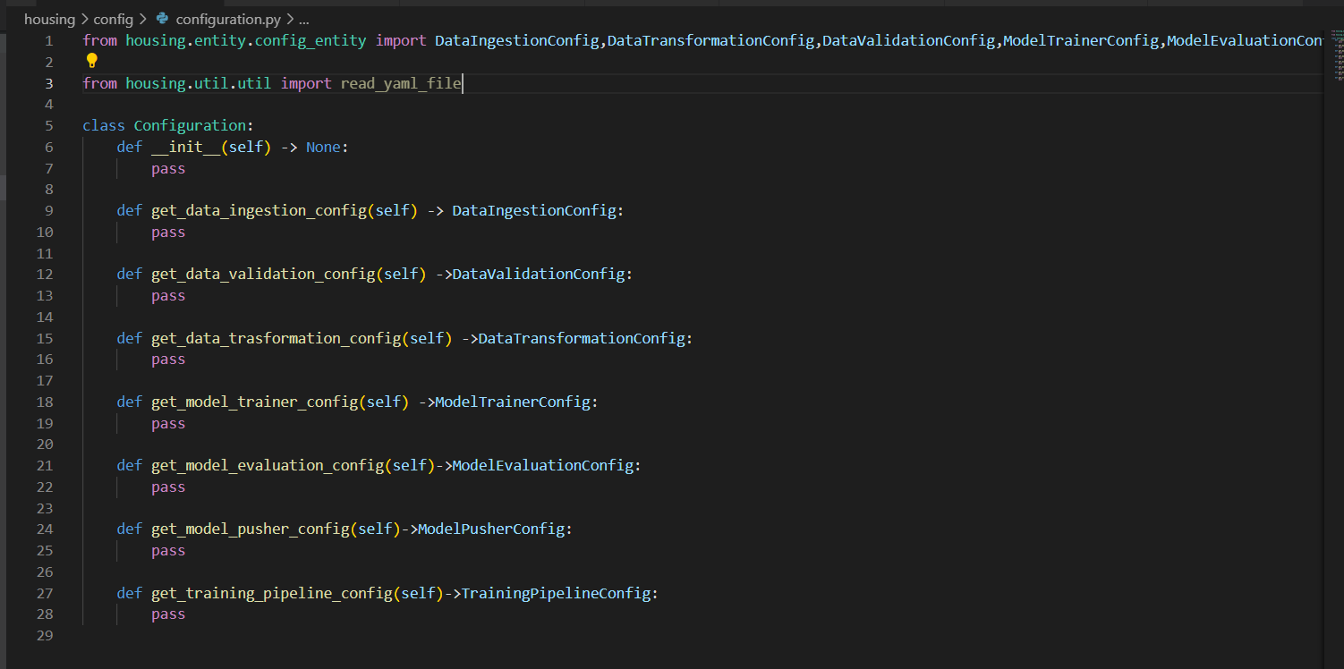

In every project we need to declare some hard coded variables

Root_DIR=os.getcwd()---- to get current working directory

So its better to create separate file for constants and declare all its constant variables

In housing- constant-__init__.py

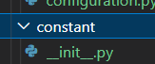

To import constants

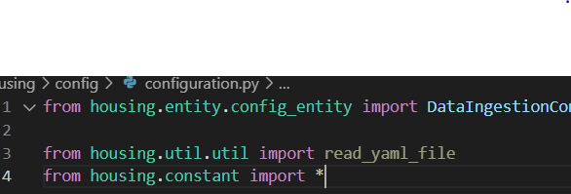

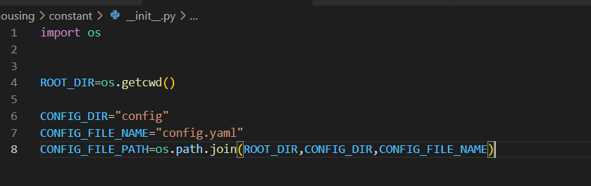

To get config_file_path to read congig.yaml

We need to create this path dynamically to work in any machine windows, mac, Linux

----------------------------------------------------------------------------------------------------------------------------------------

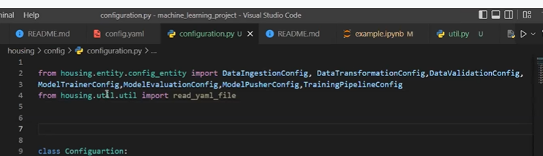

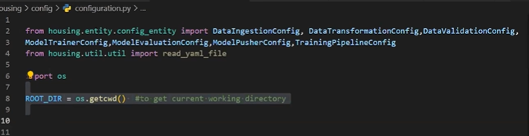

Instead of creating constants here

Its better to create separate folder for constants as well

Within housingfolder

Create constant folder

Under that __init__.py

In constant

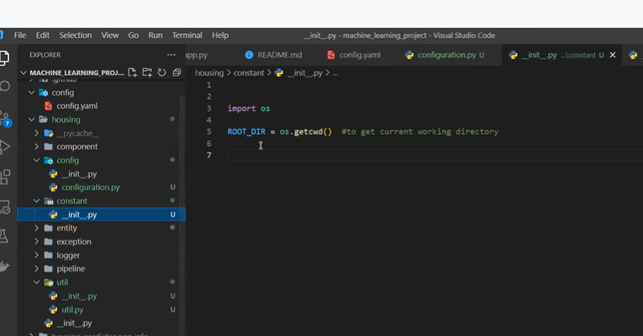

Now

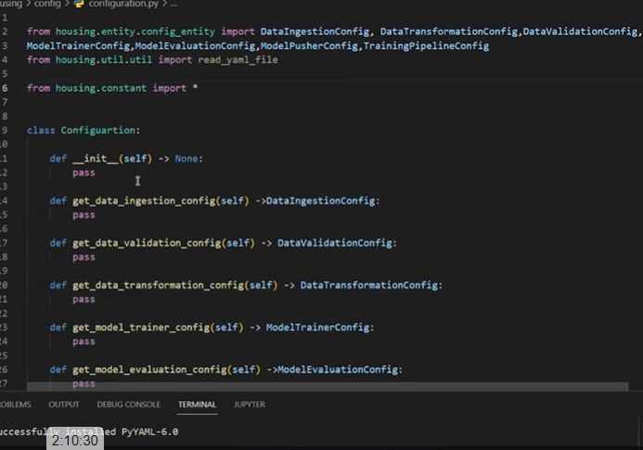

Constant